CURRICULUM VITAE
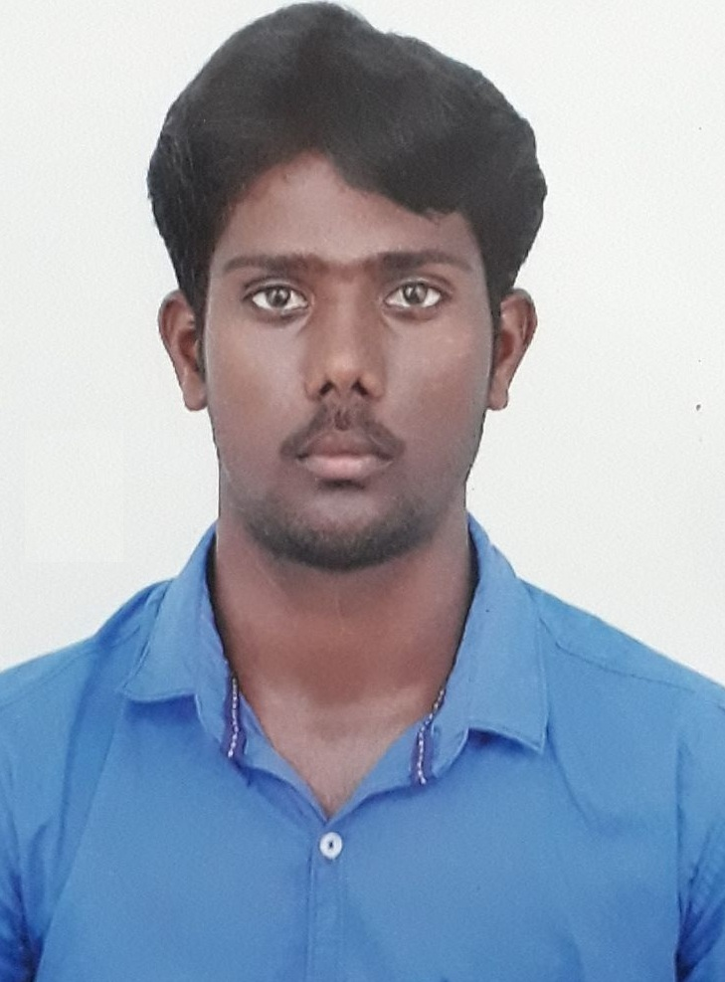
NAME: ESAKKIAPPAN.T | POSITION: MECH- ENGINEER
NATIONALITY:INDIAN | DATE OF BIRTH:12/07/199CURRICULUM VITAE2
TOTAL EXPERIENCE: 3 YEAR 6Month | Mob:(INDIA) +91 8778470279
Email :esai.1992@gmail.com | Passport No: Z2938147
ACADEMIC QUALIFICATION:
BE (Mechanical Engineering)- Dr.SivanthiAditanar College of Engineering, Anna University, Chennai.
OTHER CERTIFICATE COURSE:
- STCW 95 (Standards of training , certification and watch keeping)
- PST (Personal survival technique)
- FF&FP(Fire fighting and fire prevention)
- BFA(Basic first aid)
- PS & SR (Personal safety & social resposibities)
THIRD PARTY TRAININGS PASSED / PARTICIPATED:
- International Workshop on participating in “TCET”, Vandavasi.
- In plant training at Thermal power plant, Tutucorin.
- Industrial visit at V.O.C port,Tutucorin.

TECHNICAL SKILL:
- Designsoftware: Auto CAD
- MS-office: Word, Excel, PowerPoint
ACADEMIC PROJECTS:
- Design and fabrication of six stroke engine.
- Design and analysis of ship hatch cover.

EXTRA CIRICULAR ACTIVITIES AND ACHIEVEMENTS:
- Attended National Service Scheme (NSS) Camp organized for SOCIAL SERVICE.
- To participated swimming (200m butterfly style) second level
- To participated ball badminton third level.
- To participated football position is runner.

CURRENT WORK EXPERIENCE:
Company : Sakthi engg pvt lmited kudankulam , Tirunelveli (Power plant).
Position : maintenance engineer
Period : October 2016to till date
Previous Assignment:
1. Company : Substation Maintenance Engineering, Malaysia.
Position : Site engineer
Project : Tower Line for Power Plant Substation 520Kv Unit.
Period : October 2015 to September 2016
2. Company : Substation Maintenance Engineering, Malaysia.
Position : Site engineer
Project : Power Plant Substation 520Kv Unit Construction.
Period : August 2014 to September 2015.
Well head at:
- Inspection the well
- Flushing of the well
- Collection of the well data
- Cleaning and greasing of well
- Pumps and compressor
- All type of valve
- Pipe line work
Functions and Responsibilities Of Entrusted: Site Engineer-
- Provide construction, installation & commissioning support.
- Analyse problems to see how mechanical and thermal devices might help solve the problem.
- Design or redesign mechanical and thermal devices using analysis and computer-aided design.
- Develop and test prototypes of devices they design.
- Analyse the test results and change the design as needed.
- Working closely on construction plans with clients, architects, and other professionals.
- Site inspection for civil works, which includes structural works and ensure that the work is as per the Project Specifications and issued for construction drawing/ final approved drawings from authorities.
- Developing design ideas using CAD software.
- Making drawings, specifications and computer models of structures.
- Ensure that all the works meets the stipulated quality standards.
- Monitor the progress of work with respect to the Master Program.
- Performing quantity survey for clients review and approval.
- Attend meetings and discuss project details with clients, contractors.
- Contractor’s submittals reviewing via, Sub-contractor’s prequalification documents, material submittals, method statements, technical documents, shop drawings, etc.
- Trained new employees in a supervisory capacity to take over similar projects and aid company expansion.
- Making sure that projects meet legal guidelines, environmental directives, and health and safety requirements.
- Completed Job Hazard Assessments to identify any hazards related to job tasks and applied safety mitigation techniques to lower risks.
Addenda:
- Ability to communicate in English, Tamil, little hindi.
- Capacity to work independently and comfortably in any multinational environment.
- Ability to work in a team.
- Ability to cope up with different situations.
- Amiable and Amicable nature.
- Zeal to learn emerging Technologies.

Hobbies:
- Surfing Net.
- Playing Cricket
- Listening to songs.
- Playing ball badminton.
PERSONAL PROFILE:
Name : Esakkiappan.T
Father’s name : Thangaraj. D
Date of Birth :12/07/1992
Nationality : Indian
Known Languages: Tamil, English,little hindi.
Marital Status : Single

Declaration:
I hereby declare that the above details furnished by me are true to the best of my knowledge and belief.
Place:
Date : (Esakkiappan.T)

